**R18 embedded PC with Rockchip 3568 chipset**

* It is equipped with Rockchip RK3568 quad core 64-bit industrial processor
* its max DDR capacity support is up to 8GB and supports full link ECC
* R18 support Wi-Fi 6, 5G/4G and other high speed wireless network communication
* R18 has industrial grade stability and can operate stably for a long time under the working temperature from -40°C to 80°C
* Company also can provide reference design data of the base plate; which users can customize with.
* It can be equipped with 8GB memory capacity at most, 32bit bit width and 1600MHZ frequency
* Support full link ECC to make data more secure and reliable, and meet the requirements of product application scenarios with large memory.

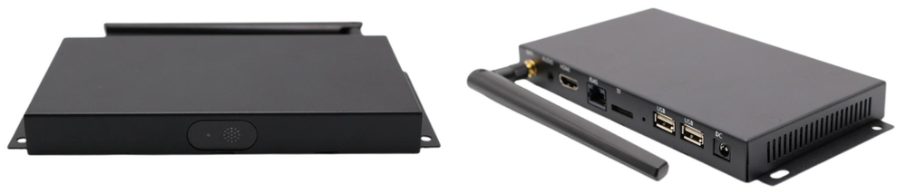

**RK3568 CPU**

The RK3568 CPU is a quad-core A55 with a main frequency of up to 2GHz. Integrated G52 GPU. Built-in independent NPU, the computing power is 0.8Tops, which can meet the multi-functional requirements of cloud office and cloud education market.

* 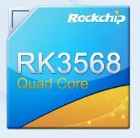Quad core 64-bit cortex - A55
* Arm G52 2EE
* LPDDR4/ LPDDR4X/ DDR4/ DDR3/ DDR3L/ LPDDR3, ECC
* Built in NPU, providing 0.8t computing power
* Support 4K 60fps H.265 / H.264/ VP9 video decoding
* Support 1080p 60fps H.265 / H.264 Video Editing
* Support 8M ISP and HDR
* Support HDMI / eDP / LVDS / MIPI / RGB / T-CON interface
* Support USB2.0/U SB3. 0/PCIE3. 0/PCIE2.1/SATA3. 0/QSGMII

**Rockchip RK3568 integrated GPU, VPU, and NPU**

* Rockchip RK3568 integrates dual core architecture GPU, VPU and NPU
* RK3568 GPU supports OpenGL ES 3 2/2.0/1.1, Vulkan1.1
* its VPU can support 4K 60fps H.265/H.264/VP9 video decoding and 1920x1080@60fps H.265/H.264 video encoding
* Its NPU supports mainstream architecture models such as Tensorflow and Caffe Mode.

**Multiple display interfaces**

* R18 has HDMI 2.0, LVDS, EDP, and MIPI video interface
* R18 can support three screens displaying different contents at the same time
* Built in 8m ISP image signal processor, which can support camera and HDR functions
* R18 can be used as digital bulletin terminal, digital signage media player and other applications.

**Various interfaces**

* R18 has HDMI, RJ45, Micro SD, USB 3.0, OTG/USB3.0, GPIO, RS232, LVDS, MIPI, EDP, earphone/microphone interfaces.

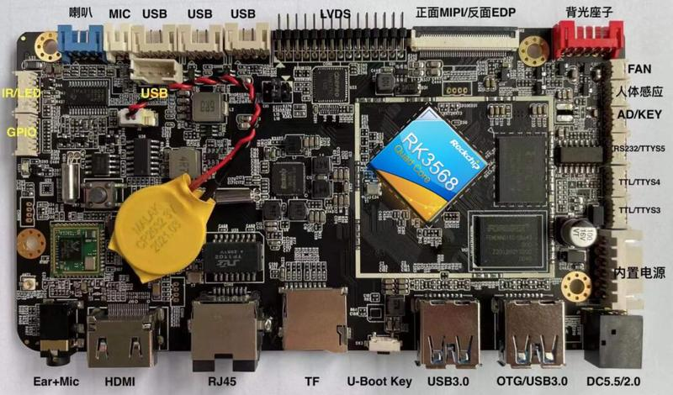

**Stable running at wide temperature range**

* With strictly select industrial grade processors and components
* R18 can run under harsh working environment, and its working temperature range is from - 40°C to 80°C
* R18 also can work continuously and stably for 24/7 for reaching the industrial standard.

**Multiple operation systems, Android and Linux Ubuntu OS**

R18 has excellent real-time performance and it can provide a safe and stable system environment for product research and production.

**To be used in different industries and applications**

R18 with Rockchip 3568 chipset, it can be widely used in IOT gateway, industrial PC, edge computing, face recognition, digital signage, intelligent device, cloud terminal, vehicle central control and other applications.

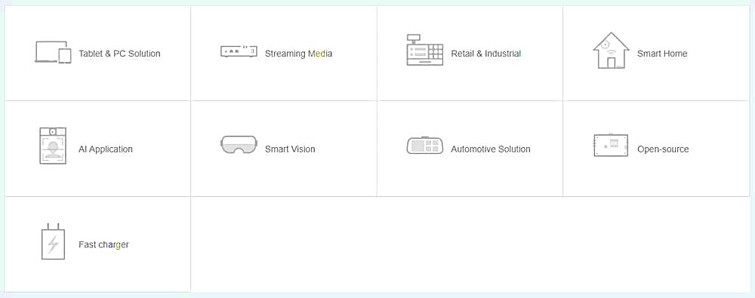

**Product Parameters**

|  |  |
| --- | --- |
| **CPU** | Quad-Core ARM Cortex-A55，up to 2.0GHz |
| **GPU** | * ARM G52 2EE  * Support OpenGL ES 1.1/2.0/3.2，OpenCL 2.0，Vulkan 1.1  * High performance dedicated 2D processor |
| **NPU** | Support 0.8T |
| **Multi-media** | * Support 4K 60fps H.265/H.264/VP9 decoder  * Support 1080P 60fps H.265/H.264 encoder  * Support 8M ISP with HDR |
| **Display** | * Support multi-display  * Support EDP/HDMI2.0/MIPI/LVDS/24bit RGB/T-CON |
| **Interfaces** | HDMI, RJ45, Micro SD, USB 3.0, OTG/USB3.0, GPIO, RS232, LVDS, MIPI, EDP, earphone/microphone interfaces |
| **Operating System** | Android and Linux Ubuntu |